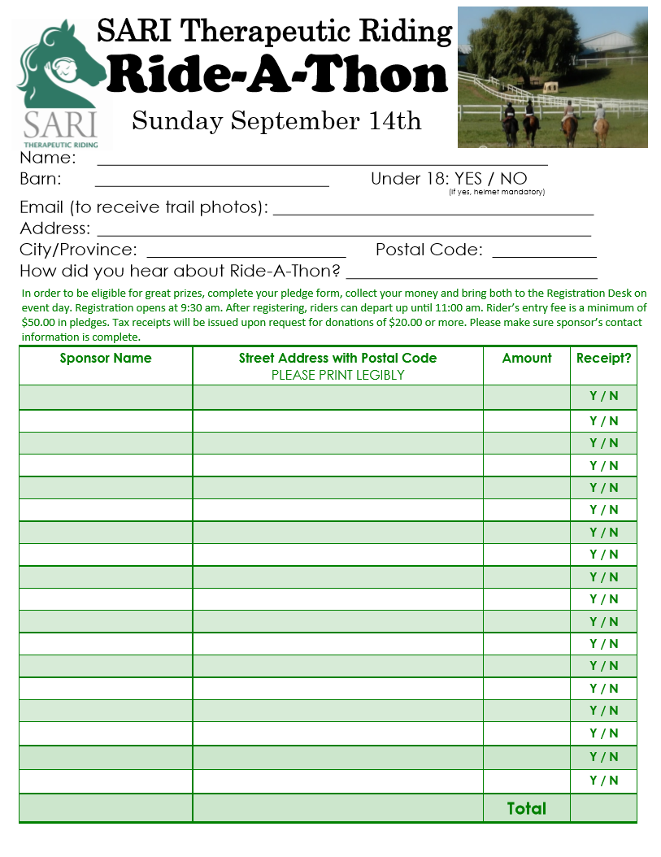

Sunday October 6th, 2019

HELMET MANDATORY AT ALL AGES

In order to be eligible for prizes, complete your pledge form, collect your money and bring both to the Registration Desk on event day. Rider’s entry fee is a minimum of $75.00 in pledges. Tax receipts will be issued upon request for donations of $20.00 or more. Please ensure sponsor’s contact information is complete.